Thurrock Disability Partnership Board
Thursday 15th December 2016 (Evening) 2016 - 5.30pm Arrival for 6pm -8pm meeting
The Beehive
Agenda
Item | Timings | Pictures | Item | Led by
 | 5:30 – 6:00pm |  | Arrival & Networking
1. | 6:00 – 6:05pm  5 minutes | 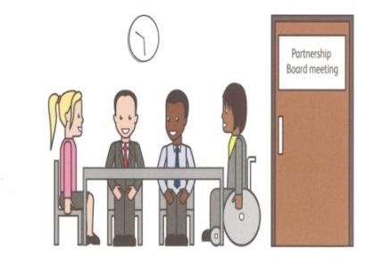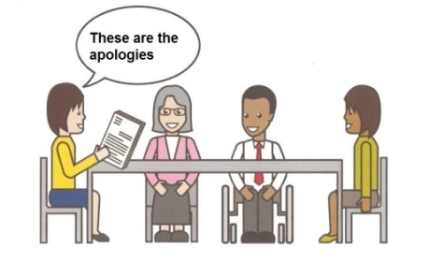 | Welcome and introductions  Apologies – People who can’t come to the meeting | Anne White  Ian Evans
2. | 6.05 – 6.10pm  5 minutes | 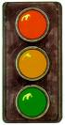 | Traffic lights, cards and rules of the meeting | Mark Fraser / Anne White
3. | 6:10-6:25 pm  15 minutes |  | Health Matters – Update on Health Matters Agenda and Action Plan based on the 18 CIPOLD Outcomes | Neil Woodbridge/ Jane Itangata
4 | 6:25-6:30 pm  5 minutes | Health & Well-Being | Update on the Health and Wellbeing Strategy feedback so far and brief  introduction to the Theme of the meeting: The Thurrock Health and Wellbeing Strategy Goal D – Quality Care Centred Around the Person | Darren Kristiansen
5. | 6:30-6:55 pm  25 Minutes |  | Discussion and Breakout Groups-Thurrock Health and Wellbeing Strategy Goal D | All
6. | 6:55-7:05pm  10 minutes |  | Breakout Group Feedback from the Discussion of the Thurrock Health & Wellbeing Strategy – Goal D | All
7. | 7:05-7:15pm  10 minutes |  | Tea/coffee/mince pie/stollen | All
8. | 7:15-7:30pm  15 minutes |  | Minutes of the previous meeting of the Disability Partnership Board:  8.1. Any amendments?  8.2. Matters Arising | All
9. | 7:30-7:40pm  10 minutes |  | Board Members Updates including:  - Thurrock Coalition  - Mental Health Forum  - Autism Action Group | All
10. | 7:40-7:50pm  10 minutes |  | Thurrock Council Update: | Les Billingham
11. | 7:50-7:55pm  5 minutes |  | Safeguarding Update | Graham Carey
12. | 7:55-8:00pm  5 minutes |  | Any Other Business
- | 8:00pm | 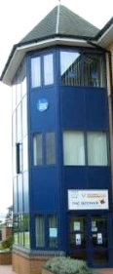 | Date and Time of next meeting:  Thursday 16th March 2017  Arrive from 5.30pm for 6pm – 8pm  The Beehive, West Street  Future Agenda Items:  TransVol Presentation – March 2017 | All

