Thurrock Disability Partnership Board
Thursday 16th June 2016 (Evening) 2015 - 5.30pm Arrival for 6pm -8pm meeting
The Beehive
Agenda
Item | Timings | Pictures | Item | Led by
1. | 6:00 – 6:05pm  5 minutes | 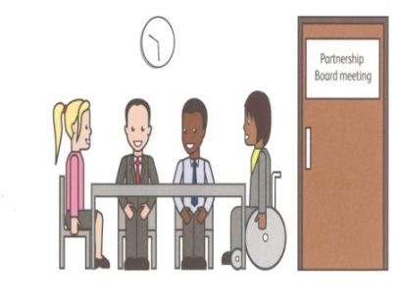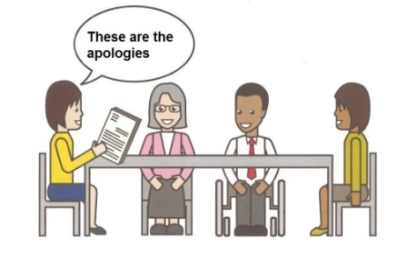 | Welcome and introductions  Apologies – People who can’t come to the meeting | Anne White  Ian Evans
2. | 6.05 – 6.10pm  5 minutes | 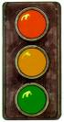 | Traffic lights, cards and rules of the meeting | Mark Fraser / Anne White
3. | 6.10 – 6.20pm  10 minutes | Health & Well-Being | Update on the Health & Wellbeing Strategy feedback so far and brief Introduction to the Theme of the Meeting: The Thurrock Health & Well-Being Strategy Goal B – Healthier Environments | Ceri Armstrong
4. | 6:20-6:50pm  30 Minutes |  | Discussion & Breakout Groups - Thurrock Health & Well-Being Strategy – Goal B – Healthier Environments | All
5. | 6:50-7:00pm  10 minutes |  | Coffee Break | All
6. | 7:00-7:15pm  15 minutes |  | Breakout Group Feedback from the Discussion of the Thurrock Health & Well-Being Strategy – Goal B – Healthier Environments | All
7. | 7:15-7:35pm  20 minutes |  | Minutes of the previous meeting of the Disability Partnership Board:  - Any amendments?  - Actions | All
8. | 7:35-7:45pm  10 minutes |  | Board Members Updates  including:  - Thurrock Coalition  - Mental Health Forum  - Autism Action Group | All
10. | 7:45-7:50pm |  | Thurrock Council Update:  - Election Outcome Update  - Advocacy Contract Outcome Update | Catherine Wilson
11. | 7:50-7:55pm | 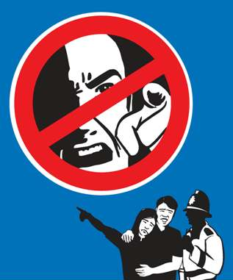 | Safeguarding Update | Graham Carey
12. | 7:55-8:00pm |  | Any Other Business | All
 | 8:00pm | 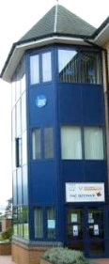 | Date and Time of next meeting:  Thursday 15th September 2016  Arrive from 5.30pm for 6pm – 8pm (Evening meeting)  The Beehive, West Street RM17 6XP | All

