Thurrock Disability Partnership Board
Thursday 17th March 2016 (Evening) 2015 - 5.30pm Arrival for 6pm -8pm meeting
The Beehive
Agenda
Item | Timings | Pictures | Item | Led by
1. | 6:00 – 6:05pm  5 minutes | 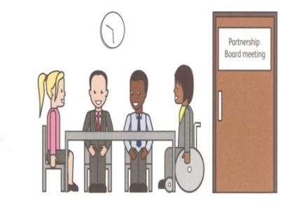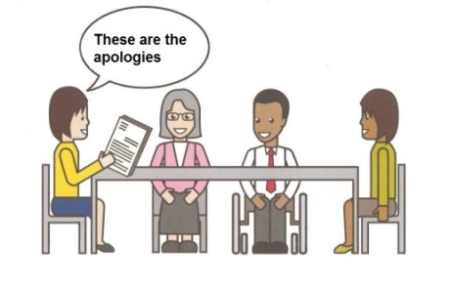 | Welcome and introductions  Apologies – People who can’t come to the meeting | Anne White  Ian Evans
2. | 6.05 – 6.10pm  5 minutes | 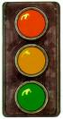 | Traffic lights, cards and rules of the meeting | Mark Fraser / Anne White
3. | 6.10 – 6.20pm  10 minutes | Health & Well-Being | Introduction to the Theme of the Meeting: The Thurrock Health & Well-Being Strategy – Goal A – Opportunity for All | Ceri Armstrong
4. | 6:20-6:50pm  30 Minutes |  | Discussion & Breakout Groups - Thurrock Health & Well-Being Strategy – Goal A – Opportunity for All | All
5. | 6:50-7:00pm  10 minutes |  | Coffee Break | All
6. | 7:00-7:15pm  15 minutes |  | Breakout Group Feedback from the Discussion of the Thurrock Health & Well-Being Strategy – Goal A – Opportunity for All | All
7. | 7:15-7:25pm  10 minutes |  | Minutes of the previous meeting of the Disability Partnership Board:  - Any amendments?  - Actions | All
8. | 7:25-7:35pm  10 minutes |  | Board Members Updates  including:  - Thurrock Coalition  - Mental Health Forum  - Autism Action Group | All
9. | 7:35-7:45pm |  | Health Matters Update:  - Health checks update following Health & Well-Being Overview & Scrutiny Committee  - Learning Disability Mortality Review | Les Billingham / Mandy Ansell
10. | 7:45-7:50pm |  | Update on experiences of organisations supporting people to access Department for Work & Pensions Home Visits | Christine Ludlow
11. | 7:50-7:55pm |  | Safeguarding Update | Graham Carey
12. | 7:55-8:00pm |  | Any Other Business | All
 | 8:00pm | 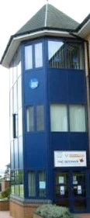 | Date and Time of next meeting:  Thursday 16th June 2016  Arrive from 5.30pm for 6pm – 8pm (Evening meeting)  The Beehive, West Street RM17 6XP | All

