Thurrock Disability Partnership Board
Thursday 15th September 2016 (Evening) 2016 - 5.30pm Arrival for 6pm -8pm meeting
The Beehive
Agenda
Item | Timings | Pictures | Item | Led by
 | 5:30 – 6:00pm |  | Arrival & Networking
1. | 6:00 – 6:05pm  5 minutes | 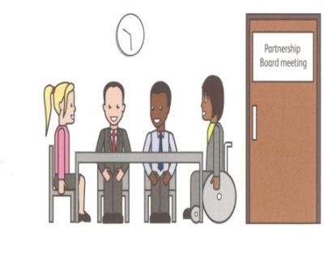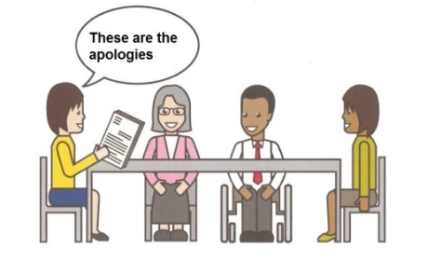 | Welcome and introductions  Apologies – People who can’t come to the meeting | Anne White  Ian Evans
2. | 6.05 – 6.10pm  5 minutes | 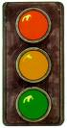 | Traffic lights, cards and rules of the meeting | Mark Fraser / Anne White
3. | 6.10 – 6.25pm  15 minutes |  | Information: Learning Disability Ladies Support Group which takes place in Grays. Followed by Questions and Answers | SERICC and Thurrock Lifestyles Solutions
4. | 6:25 - 6:35pm  10 Minutes | Health & Well-Being | Update on the Health and Wellbeing Strategy feedback so far and brief  introduction to the Theme of the meeting: The Thurrock Health and Wellbeing Strategy Goal C | Ceri Armstrong
5. | 6:35 – 7:00pm  25 Minutes |  | Discussion and Breakout Groups-Thurrock Health and Wellbeing Strategy Goal C | All
6. | 7:00 – 7:10pm  10 minutes |  | Coffee Break | All
7. | 7:10-7:20pm  10 minutes |  | Breakout Group Feedback from the Discussion of the Thurrock Health & Well-Being Strategy – Goal C | All
8. | 7:20-7:35pm  15 minutes |  | Minutes of the previous meeting of the Disability Partnership Board:  - Any amendments?  - Actions | All
9. | 7:35-7:45pm  10 minutes |  | Board Members Updates including:  - Thurrock Coalition  - Mental Health Forum  - Autism Action Group | All
10. | 7:45-7:50pm  5 minutes |  | Thurrock Council Update:  - Medina Road Project  - Accessibility of Partnership Board Meetings | Les Billingham
11. | 7:50-7:55pm |  | Safeguarding Update | Graham Carey
12. | 7:55-8:00pm |  | Any Other Business  - Learning Disabilities Health Checks Update | All  Mandy Ansell
- | 8:00pm | 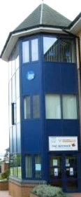 | Date and Time of next meeting:  Thursday 15th December 2016  Arrive from 5.30pm for 6pm – 8pm  The Beehive, West Street | All

