Thurrock Disability Partnership Board
Tuesday 16th December 2014 - 9.30am Arrival for 10am -12 noon meeting
The Beehive
Agenda
Item | Timings | Pictures | Item | Led by
1. | 10:00am – 10:05am | 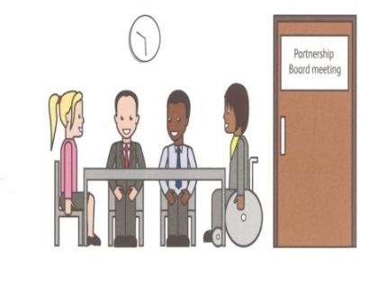 | Welcome and introductions | Anne White
2. | 10.05 – 10.10 | 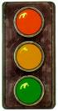 | Traffic lights, cards and rules of the meeting | Mark Fraser / Anne White
3. | 10.10 – 10.15 | 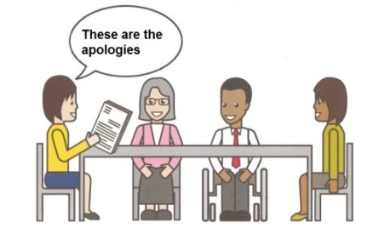 | Apologies – People who can’t come to the meeting | Kelly Jenkins
4. | 10.15 – 10.25 |  | Matters arising (accuracy) (content) | Anne White
5. | 10.25 – 10.40 |  | Health Matters – Update on the protocol for Health and Social Care around access to services for sensory service users.  Discussion on experiences of accessing these services and how to improve this  Health Checks – Update on the number of people in Thurrock who have had their health check and plans for the future  CIPOLD - Confidential Inquiry into premature deaths of people with learning disabilities (progress on the 18 recommendations – how these are being achieved) How is personal information shared between providers? | Mandy Ansell (CCG)  Natalie Warren (Diversity Team)  All
6. | 10.40 – 10.50 |  | Equality Impact Group Update – Terms of Reference, invite membership | All
7. | 10.50 – 11.00 |  | Coffee break | All
8. | 11.00 – 11.10 |  | Safeguarding  Easy Read of “No Secrets” Update | All  Graham Carey
9. | 11.10 – 11.20 |  | Board Members Updates (including Anne’s Update & Thurrock Coalition) | All
10. | 11.20 – 11.55 |  | Communicating the Care Act and what it will mean for people in Thurrock | Les Billingham /Ceri Armstrong/Ian Evans /Rhodri Rowlands
11. | 11:55 – 12 noon |  | AOB – Self Assessment Framework  TDPB Proposed Future meeting schedule / dates | Kelly Jenkins  Les Billingham / Anne White
12. | 12 noon | 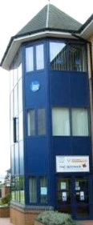 | Date and Time of next meeting:  March 2015  To be finalised | All

