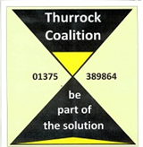

**Date: Monday, 14th July 2014**

**Time: 2pm to 4pm (arrive from 1:30pm)**

**Venue: The Beehive, West Street, Grays RM17 6XP**

**Agenda:**

**1. Welcome & Introductions**

**2. Minutes & Matters arising from the previous Forum Meeting (May 2014)**

**3. Written Update from Bill Clayton re: Workforce Development - MH Training & Awareness**

**4. Assigning Questions on Housing Allocations for MH Service Users (TCIL)**

**5. Coffee Break**

**6. Q & A and discussion on Housing Allocations for MH Service Users (TCIL)**

**7. AOB – including future meeting topics**

**8. Date of Next Forum Meeting – Suggest: 15th September 2014**

**Thurrock Mental Health**

**Service User & Carer Forum**