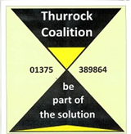

**Date: Monday, 26th January 2015**

**Time: 2pm to 4pm (arrive from 1:30pm)**

**Venue: The Beehive, West Street, Grays RM17 6XP**

**Agenda:**

**1. Welcome & Introductions**

**2. Minutes & Matters arising from the previous Forum Meetings on PHBs (October 2014)**

**3. Presentation on Adult Safeguarding & Mental Health**

**4. Q & A and Discussion on Safeguarding & Mental Health**

**5. Coffee Break**

**6. Discussion and agreement for future meeting topics. E.g. Community Safety, Essex Police, PHB Update**

**7. AOB – including future meeting dates**

**8. Date of Next Forum Meeting – Suggest: Monday, March 23rd 2015 at 1:30pm**

**Thurrock Mental Health**

**Service User & Carer Forum**