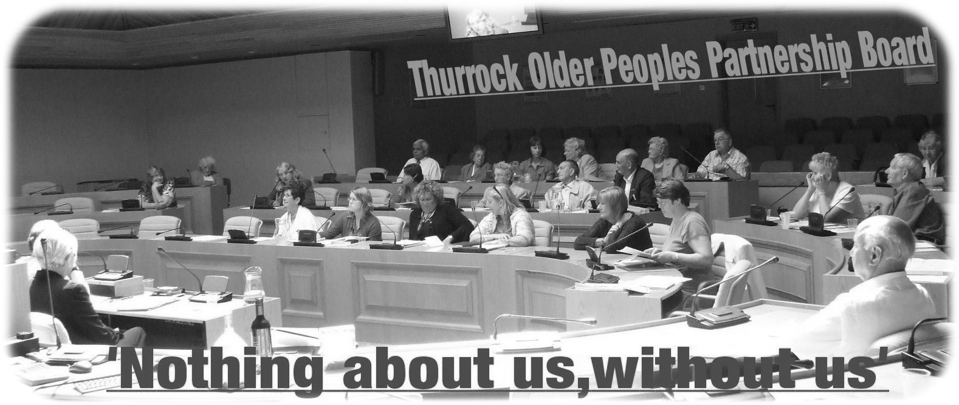

Thurrock Older Peoples’ Parliament

Minutes of the meeting held on Tuesday 2nd April 2013
In the Council Chamber, Civic Offices, New Road, Grays
Present :

Brian Horne, Chairperson
Gerry Calder, Vice Chairperson
Brian D’Arcy, TOFF
Jean Patnell, TOFF
Olga Benson, TOFF & TDN
Glynis Petit – Age Concern Thurrock
Terry Brown –Tilbury Community Forum
Cllr Yash Gupta
Sue Reeman – Thurrock Council - representing Sue Kane,
Sheltered Housing Manager
Ian Evans – Thurrock Coalition
Sarah Turner – Thurrock Council – Older Peoples Commissioner
Ceri Armstrong – Thurrock Council – Strategy Officer

Apologies:

Aby Carew – Thurrock Council
Daphne McCambridge - SEPT
Gill Close – Pensions service
Jo Hall – Thurrock Council
Les Billingham – Thurrock Council
Maralyn Sibbons – Thurrock Council
Matthew Kiely – Thurrock Council
Mike Rawlings – Citizens Advice Bureau

Key:

TOFF – Thurrock Over Fifties Forum
LINK – Local Involvement Network
U3A – University of the 3rd Age
SCOOT – Stanford-le-Hope Older Peoples Club
FE – Future East (The Regional Forum on Ageing)
EOPPG – Essex Older Peoples Partnership Board
SWEPT – South West Essex Primary Care Trust
TDN – Thurrock Disability Network
DAB – Citizens Advice Bureau
A.C.Thurrock – Age Concern Thurrock
- Welcome and Introductions

Brian Horne welcomed those present to the meeting and introductions were made.
- Minutes of the last meeting  The minutes of the last meeting were not available to be agreed. | ACTION
- Matters Arising  Unable to discuss any matters arising from the previous meeting as minutes of the meeting were not available. | ACTION
- Overview of current and future arrangements for Thurrock Older Peoples Parliament  Sarah Turner advised that her role was to support the Older Peoples’ Parliament and that Susan Rollings would be taking the minutes of the meetings in the future. She further explained that other Partnership Boards have agreed to use the Terms of Reference prepared by Ian Evans, Thurrock Coalition.  Sarah advised that Brian and Gerry both felt that there should be a Thurrock Council Head of Service as co-chair of the Older Peoples’ Parliament, as there is with the other Partnership Boards. Les Billingham has volunteered to take this role, which would provide a direct link to the Health and Well-Being Board. Gerry said that he believed that to have Les Billingham as a co-chair would put the group on a stronger footing and he supported the motion. Olga thought that Les Billingham would be very effective and agreed to the proposal. Councillor Gupta also thought that Les Billingham would be an effective co-chair and would help to strengthen the voice of the group by having a senior Council Officer to move matters forward. and he agreed to the proposal. A vote was taken on this proposal and was unanimously agreed by those present. | ACTION
- Older Peoples’ Parliament Terms of Reference – Ian Evans  Ian explained that he is the programme co-ordinator for Thurrock Coalition and he gave an overview of how the Coalition supports the other Partnership Boards. He explained that the purpose of the Partnership Boards was to involve people and talk about strategic planning. Other Partnership Boards have adopted the proposed Terms of Reference. The Partnership Boards are: the Disability Partnership Board, the Mental Health Partnership Board and the Older Peoples’ Parliament. Gerry explained that TOFFS will retain its own identity – it is not a Partnership Board and will not be organising the Older Peoples’ Parliament meetings.  Ian advised that it is proposed that all Partnership Boards should follow the Social Model of Disability, which Thurrock Council adopted in 2001 and the Equality Act, to include as many people as possible throughout the Borough.  It is proposed that the Older Peoples’ Parliament will meet every three months and will share information with the other Boards. Members of other Boards can always be invited to feedback at an Older Peoples’ Parliament meeting. Ideas and issues will be brought to the meeting for decisions and actions to be taken to improve services for people living in Thurrock. Ian suggested that an Action Log be created to ensure all actions are progressed. Other Partnership Boards’ action logs will be available on the Coalition website. Partnership Board reports will feed into the Health and Well-Being Board.  The draft Terms of Reference state that communication with people will be via email or paper documents. Agendas and minutes of all Partnership Boards will be on the Thurrock Coalition website – http://www.thurrockcoalition.co.uk/partnership_boards.html. Gerry thought that the Age Concern website was the appropriate site for Older Peoples’ agendas and minutes rather than a ‘disability’ website. Ian explained that there was no specific reference to disability on the relevant page on the Coalition website.  It also states in the draft Terms of Reference that all paperwork will go out two weeks before a meeting and that administrative support will be provided. Advocacy support can also be provided.  Anyone with a position of responsibility on the Board will be required to have a Criminal Records Bureau (CRB) check. | ACTION  Action log to  be created  CRB checks to be carried out
Copies of the draft Terms of Reference were passed to those present to read and consider. They were open to discussion and will be voted on at a future meeting.  There was a discussion regarding the age definition of “older people”. Gerry advised that TOFF was a forum for anyone over 50 years old and Glynis stated that Age Concern services were for people over 50. | ACTION  Vote on Terms of Reference
- Health and Well-Being Strategy – Ceri Armstrong  Ceri gave background information regarding the Health and Well-Being Board. She explained that Thurrock has had a shadow Board since April 2011 but from the 1st April 2013 it became a statutory board whose purpose was to improve the health and well-being and reduce health inequalities of people living in Thurrock. Such boards have been created throughout the country. The Board is a partnership board made up of Councillors, Council Officers, Health colleagues, Healthwatch and the Community Safety Partnership’s Chair. It is the Board’s responsibility to develop a Joint Strategic Needs Assessment and develop a Health and Well-Being Strategy which capture the Borough’s health and well-being priorities. These documents drive commissioning decisions. There are two parts to the strategy – one for children and one for adults. The strategy is for three years – with one year delivery plans. The suggestion is that Partnership Boards will monitor the delivery of actions and identify if outcomes are being achieved. Ceri thought that the Older People’ Parliament may wish to think about their role in considering the actions of the Health and Well-Being Board. A copy of Ceri’s presentation was handed to those present.  Gerry advised that he had been told that Basildon Hospital was short of 93 beds recently and was concerned that this may become the usual situation. He asked who this matter could be referred to. Ceri advised that HWBB has spoken to the Hospital’s Chief Executive. Brian was concerned that increases to the population in Thurrock would cause further strain on NHS resources and he would like to know what forward planning was in place. Olga enquired about patients being able to select a hospital for treatment. Ceri advised that the “choice” agenda will continue. Both Sarah and Ceri advised the group that they could invite Health representatives to a meeting to ask their questions directly.  Sarah suggested that the group work out what themes/questions they would like to raise at their meetings, i.e. housing, health transport etc. If the group wished to invite specific representatives | Consider role of monitoring actions of the Health & Well-Being Board
she thought that it may take up to six months to be able to get a senior representative to attend one of the group’s fixed dates. Sarah suggested that at the next meeting it should be decided what topics/questions the group want to discuss. Gerry thought there should be standard items on the agenda – i.e. Healthwatch. Gerry also thought they should be working with the Housing Department.  Gerry said that he would like all Councillors to be sent a copy of the minutes. Sarah explained that a copy of the minutes will be sent to the Members’ secretary. | ACTION  Agenda items next meeting
- Updates  Gerry Calder gave a summary on Healthcheck, saving energy, switching energy supplier, older people enrolling for adult education and a recent Healthwatch event. He also alerted people to a cold calling scam regarding housing (two men have been arrested).  The TOFF petition to stop telephone cold calling continues and you can sign up at www.youtube.com/user/tofftwo  TOFF REPORT  New funding reforms announced for care and support.  See Appendix 1.  Glynis advised that Age Concern have merged with Help the Aged and are now called Age UK. They now have an outreach helpdesk at the new South Ockendon centre. She has been meeting with older people across the Borough. During the past year they have compiled a list of groups and services available locally. A newsletter is also sent out and any ideas for the paper would be gratefully received. She has also been warning people of the same scam mentioned above. | ACTION
- Any other business  Gerry thought that the Older Peoples’ Parliament should have headed paper that includes “Nothing about us without us” for when the group write externally. Sarah agreed to see if she could pull something simple together. | ACTION  Sarah to look at creating a header that can be used
Date and time of next meeting

Tuesday 9th July 2013 at 10.00 a.m.

Council Chamber, Civic Offices, Grays

Appendix 1 TOFF UPDATE
New funding reforms announced for care and support

11 February, 2013
The Government has announced new measures for funding care to ensure that the elderly and those with disabilities get the care they need without facing unlimited costs.
The new measures are based on the recommendations made in 2011 by the Dilnot Commission, an independent panel set up to look at the fairest and most sustainable way to fund care and support in England.
The new measures include, from April 2017:
- A cap on care costs, which gives everyone the reassurance that they will have a level of protection, if they have the most serious needs and incur very high care costs.
  - If someone is assessed by their local authority as having eligible care needs, they will be told how much it will cost the local authority to meet those needs with local services. These costs count towards their cap. So, however great a person’s costs become, once they have reached the cap the state will step in and provide financial support.
  - Due to the economic circumstances, we are introducing a cap that is equivalent to around £61,000 in 2010/11 prices – slightly above the £25,000-£50,000 range originally recommended by Andrew Dilnot. This is equivalent to £75,000 in 2017/18 prices. We expect up to 16% of older people to face costs of £75,000 or more.
  - People of working age who develop care needs before retirement age will benefit from a cap that’s lower than £75,000. People who have care needs before they turn 18 will effectively have their cap set at zero.
- New financial protection for those with modest wealth. People with the least will get the most support.
  - Currently only those with assets of less than £23,250 get help with paying for their care costs. Our changes will mean that those with property value and savings of £100,000 (in 2010/11 prices) or less will start to receive financial support, with the Government paying a proportion of their residential care costs on a sliding scale. £100,000 was the amount recommended by Andrew Dilnot, and is equivalent to around £123,000 in 2017/18 prices. The most financial support will go to those with the greatest care needs and the least in savings or home value, and the poorest people will continue to have the majority of their care costs paid.
And from April 2015:
- No-one will have to sell their home in their lifetime to pay for residential care. If people cannot afford their fees without selling their home, they will have the right to defer paying during their lifetime.
- People will have clearer entitlements. A national minimum eligibility will make access to care more consistent around the country, and carers will have a legal right to an assessment for care for the first time.
The Government will legislate for these proposals. Subject to the passage of legislation, the changes above will take effect from April 2017 and will provide people with a new legal right to financial protection from very high care costs, from the state, which has not existed previously.
The 2017 timing will ensure that these changes are affordable and sustainable for the long term.

